Breakpoint Hit Count
Breakpoint Hit Count is used to keep track of how many times the debugger has paused at some particular breakpoint. You also have some option like to choose when the debugger will stop. "Breakpoint Hit Count" window having the following:
- Break always
- Break when the hit count is equal to a specified number
- Break when the hit count is a multiple of a specified number
- Break when the hit count is greater than or equal to a specified number.
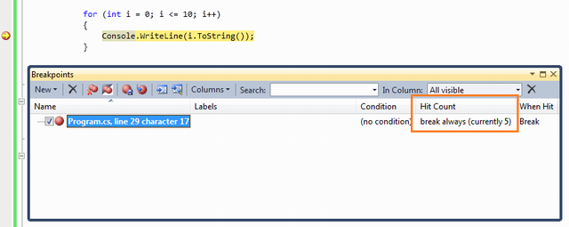

By default, it's set to always. So, whenever the breakpoints hits, hit count will increase automatically. Now we can set some condition as earlier mentioned. So based on that condition, breakpoint will hit and counter will be increased.
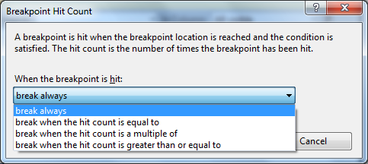
Figure: Breakpoint Hit Count Options
Let's explore it with the sample code block below:
for (int i = 0; i <= 10; i++)
{
Console.WriteLine(i.ToString()); // Breakpoint
}
If you want your code to break when hit count is a multiple of 2, you need to select the third option from the dropdown list. After that, your code line should break only when the hit count is 2,4,6,... etc.
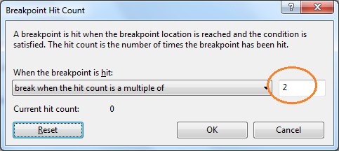
Figure: Hit Count Condition

#include<iostream>
using namespace std;
int main()
{
int i=0;
int cnt=0;
int a=10;

while(i<10)
{
i++;
cout<<i<<endl;
}

return 0;
}

In the above code place the breakpoint at “i++” statement of while loop.
Press F5 to debug , u will notice the value of i is 0 in watch window.
Now inside “BreakPoints” window , right click on “filename.cpp,line no….” select “Hit count” and try out all the options.
Press F5 to check whether it is working according the “Hit count” u have set.

